

**Employee Management System**

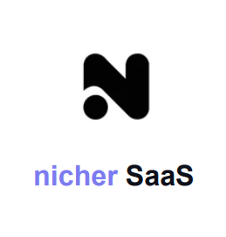

Apr Report by:

2023 Saurav Kapadiya (202001033)

Aditya Joshi (202001059)

**Abstract**

This report includes a development presentation of an information system for managing the staff data within a small company or organization. The system as such as it has been developed is called Employee Management System.

Employers could gain insight into their employees via an employee management system, which allows them to better plan and manage work hours, lowering labor expenses and increasing productivity.

Nicher SaaS (Employee Management System) solves every kind of problem that arises in a company, either that be employee related or HR related.

**Table of Contents**

1. Introduction

2. Modules and Design goals

3. Requirements

3.1 Functional Requirements

3.2 Non-Functional Requirements

3.3 User requirements

4. Use case diagram

5. Class diagram

6. Implementation

7. Interim Prototype Implementation

1. **Introduction**

An employee management system is a software platform that helps employees’ information, tasks,managing leaves and performance.

The primary goal of an employee management system is to streamline and automate HR processes, reduce administrative workload, and enhance employee experience and productivity. It provides HR with real time real time access to relevant employee data, enabling them to make informed decisions and take timely actions.

The system also benefits employees by providing them with self-service tools to manage their personal information, schedule and benefits. It promotes transparency and communication between employees and HR departments, leading to better engagement and retention.

Overall, an employee management system is a critical tool for modern organizations that want to manage their human resources effectively, efficiently and compliantly. It helps them attract, retain and develop top talent while ensuring regulatory compliance and reducing HR-related risks.

**Modules**

Employee information management,Employee schedule monitoring, monitor working days and holidays , Set leave processes , salary status ,experience ,and generate reports.

**Design goals**

* *Efficient Data Management:*

The system should be designed to efficiently manage employee data, including personal details, job roles, attendance history, and performance information.

* *Streamlined Processes:*

The system should automate routine processes such as onboarding, leave requests, and payroll, to reduce the burden on HR personnel and improve overall efficiency.

* *Security and Privacy:*

The system should have robust security features to protect employee data and prevent unauthorized access, as well as comply with data privacy regulations.

* *User-Friendly Interface:*

The system should have a user-friendly interface that is easy to navigate, intuitive and accessible to all users.

* *Scaling:*

Large number of employees might be using the system.

● Reliability

● Backward compatibility.

● Rapid Development.

● Understandability.

● Flexibility of requirements.

1. **Requirements :**

**3.1 Functional requirements :**

●*Login for different categories / level of users* ***:***

This feature is used by the user to login into the system. A user must login with his username and password to the system after registration.If they are invalid, the user is not allowed to enter the system.

- Username and password will be provided after user registration is confirmed.

- Passwords should be hidden from others while typing it in the field.

● *Employee profile :*

Employees must be able to view the system and their profile.

● *Attendance management system :*

The system offers scheduling and attendance tracking to ensure compliance with staffing needs.

● *Leave application :*

Employees can submit their requests and managers can review and approve them.

● *Employee performance report :*

This feature helps managers to set goals, provide feedback and conduct performance evaluations to ensure employees are meeting job expectations.

● *Payroll management :*

Payroll management helps administer accurate financial records of employees. It keeps track of their details- Salaries,incentives, benefits,bonuses,deductions and net pay.

● *Expenses and allowances :*

It helps organizations manage and track their employees’ business related expenses and allowances and managers to review and approve them.

● *Company information & profile :*

A directory of all employees in the company, including their contact information, job title , department and location. Individual profile of each employee, containing their personal information.

**3.2 Non-functional Requirements :**

* **Usability Requirement**:

A The web application is designed for a user friendly environment and ease of use.

* **Database Requirements:**

NoSQL database that stores and retrieves the data at the highest level possible speed. Various models for data storage are required.

* **Security Requirements :**
* Password encryption is required for safety.
* Cookies or session generation for creating user specific features.
* Security and login for users.
* **Implementation Requirements :**

Implementation of the system using Flutter in front end, Node.js for backend and Passport.js for authentication and the database part is developed by MongoDB as NoSQL database.

* **Database Security :**

Unauthorized person cannot access the panel and database and do not read and write the information.

* **Availability :**

The website will be available for maximum possible time.

* **Intuitive user experience and design :**

The user interface should be simple and intuitive, with easy to use navigation and clear labeling. Consistency in design key to creating an intuitive experience.

* **Maximum Scalability :**

The system should be handled for a large number of employees with varying levels of access and permissions for different user roles.

**3.3 User Requirements :**

**User Categories:**

*Employee:*

The lower layer of users, who get a few selected feature access and for only himself/herself.

*Manager:*

Higher level of users, who get a few selected features for other users too.

**User Needs:**

*Employee*

* View his/her profile.
* View his/her attendance history.
* View his/her performance metrics.
* View his/her salary status.
* Apply for leave and see the status of his/her leave application.
* View department details

*Manager*

* Create an Employee profile.
* Approve or reject leave applications.
* View attendance of employees.
* All other features and perks offered to employees

**Use Case Model:**

A use case model defines the various actions or tasks that users can perform within the system. For an employee management system, some potential use cases might include:

Registering a new employee profile.

Show employee profile page.

Show salary status page.

Managing the employee attendance history.

Applying for a leave(leave application form).

1. **Use case diagram :**

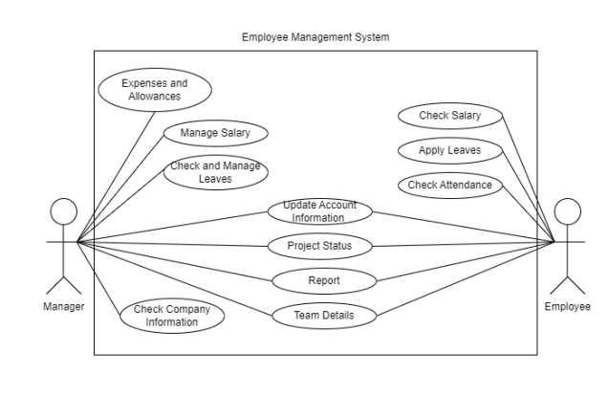

1. **Class diagram :**

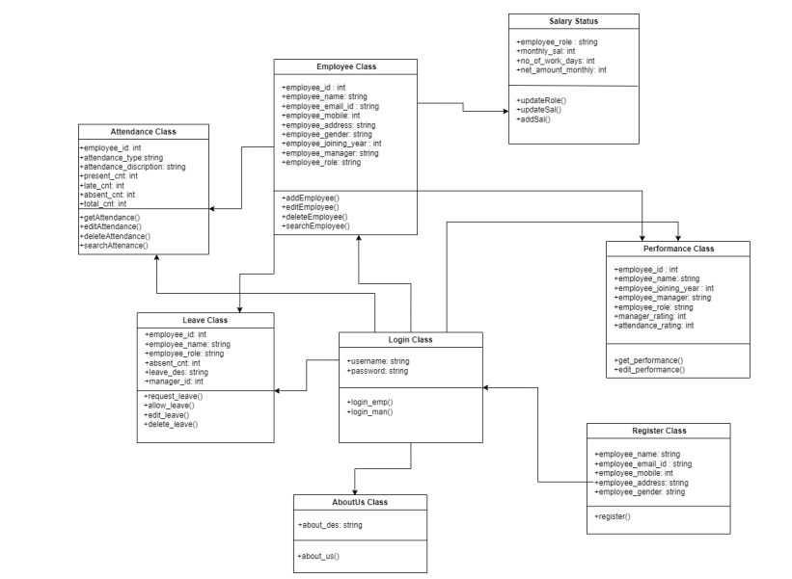

1. **Implementation**

**Flutter for Frontend:**

For the purposes of our project, we opt to work in frontend using Flutter language. Flutter is one of the best solutions to develop apps for Android and iOS, without having to write in a different codebase for each platform. The smartphone versions of these apps function as true, native apps on Apple and Android devices and are compiled for the respective platform before publication. They do not need a runtime module or a browser. Some of the benefits of flutter are:

1. One codebase for all platforms

‍2. “It’s all Widgets” principle offers countless possibilities

3. Rich libraries

4. Fast testing with hot reload

**Node.js for backend:**

For the purpose of our project, we opt to work in the backend using Node.js language. Node.js is a JavaScript run-time environment built on Chrome's V8 engine, not a framework or library. It enables server-side execution of JavaScript code. Node.js is also an open-source platform, allowing greater freedom to develop real-time network applications. It provides asynchronous, event-driven I/O APIs to developers. All executions become non-blocking since it operates on a single-threaded event-based loop.

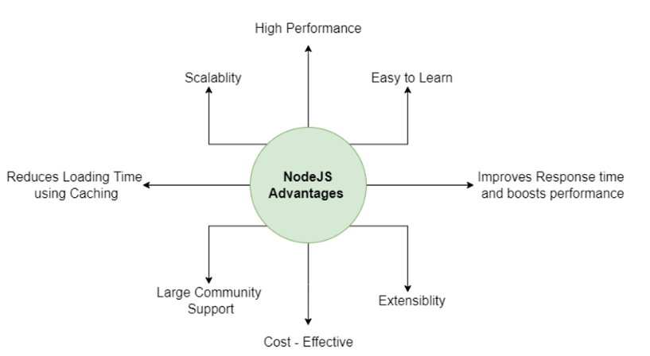

**MongoDB as NoSQL database:**

For the purpose of our project, we opt for MongoDB as a NoSQL database. Database selection plays a significant role in overall product development. How seamlessly you can edit, update, retrieve or delete depends on the database you choose. Of the two database types – non-relational and relational databases, you must choose the best fit based on your individual needs. You would have probably heard about the most in-demand database MongoDB, which is NoSQL and a very popular document database. In this article, we attempt to touch upon the reasons for the increased popularity of MongoDB.

MongoDB, a document-based NoSQL database, is a schema-less database with compelling characteristics and salient features that allows users to query data in the most straightforward and tech-savvy way. The database supported with JSON-style storage enables users to manipulate and access data with no hassles.

**Passport.js for authentication:**

For the purpose of authentication in our project, we opt for Passport.js. Passport is authentication middleware for Node.js. Extremely flexible and modular, Passport can be unobtrusively dropped into any Express-based web application. A comprehensive set of strategies support authentication using a username and password, Facebook, Twitter and more.

1. **Interim Prototype Implementation**
2. **Logo Page**

In the startup of the application, it shows our company’s logo.

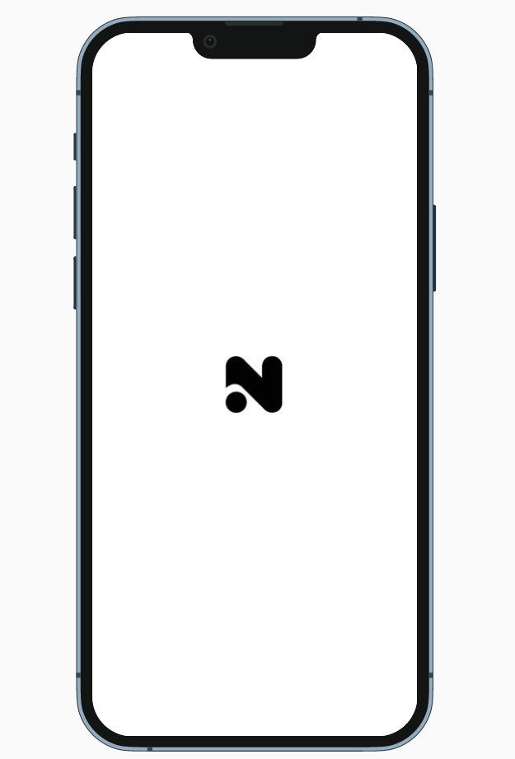

1. **Welcome Page**

After the logo page, the application displays a welcome page.

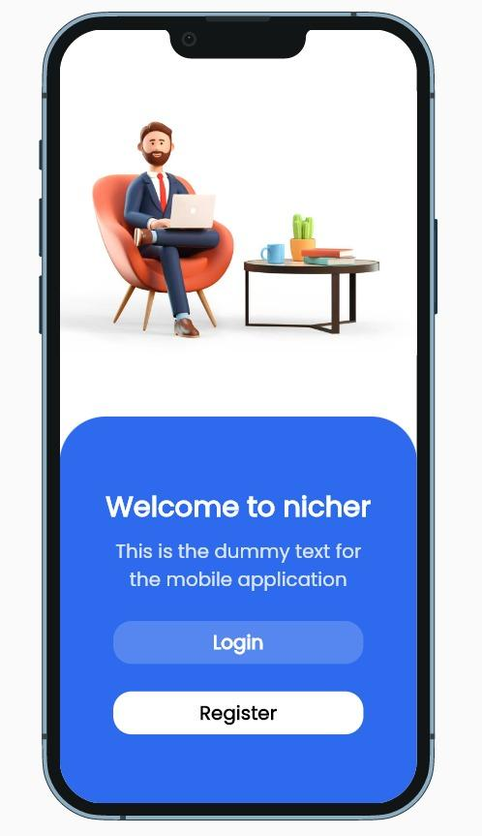

1. **Login Page**

Then this application asks the user to login, either as an employee or manager of the company.

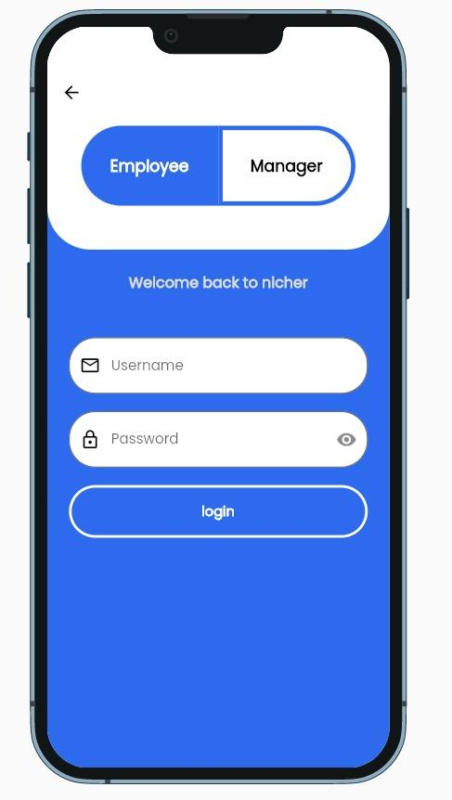

1. **Homepage for employees**

This is the homepage shown when the user logged in identifying as an employee.

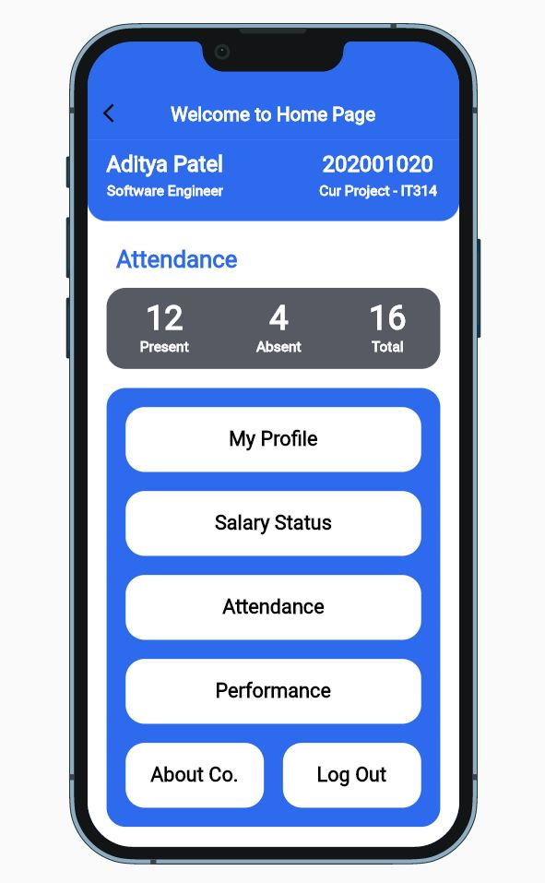

1. **Homepage for managers**

This is the homepage shown when the user logged in identifying as a manager.

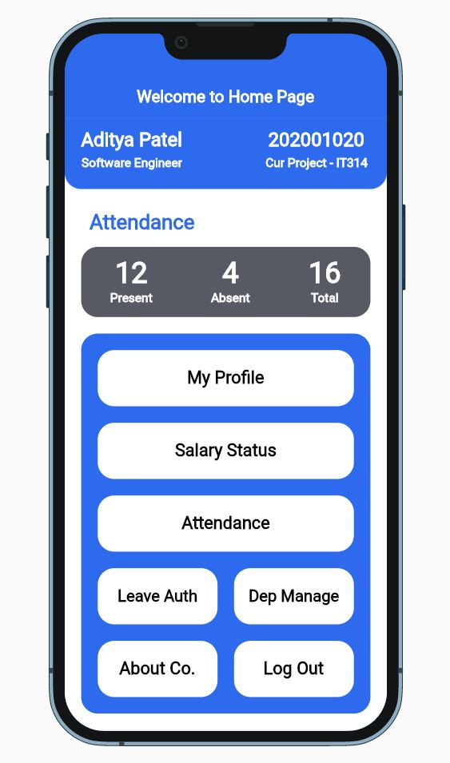

1. **Company Profile Page**

This is the company’s profile page (About Us page).

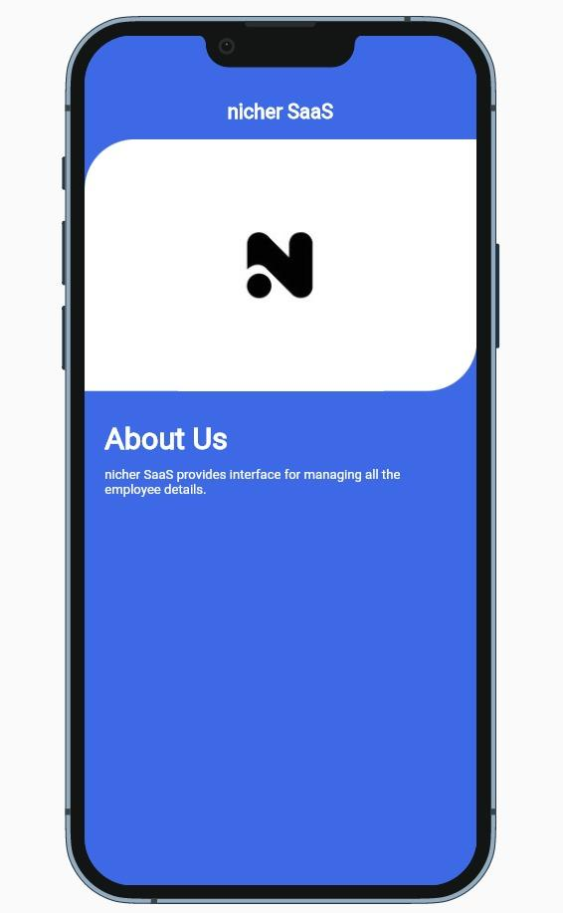

1. **Salary Status**

If an employee wants to check the status of his/her salary, he/she can go or navigate to the salary page which is shown below.

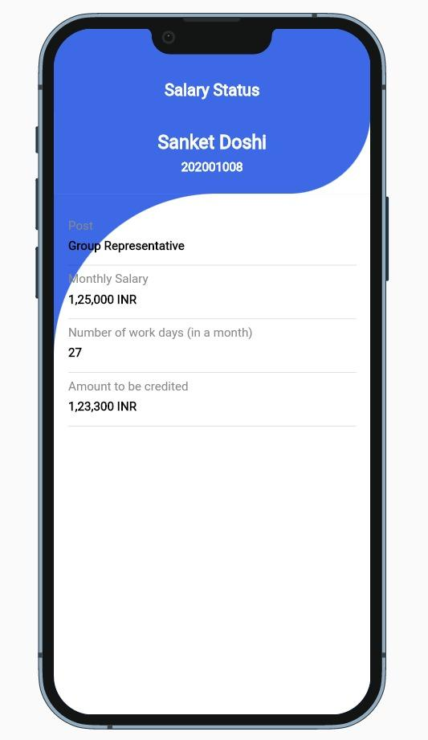

1. **Profile Page**

An employee or a manager can update or view his/her profile by navigating to the profile in the app(shown below)

